JOB PORTAL SYSTEM

MINI PROJECT REPORT

ADVANCED INTERNET PROGRAMMING (25CAP-656)

Submitted By

Anubhav Yadav (25MCD10057)

in partial fulfillment for the award of the degree of

Master of Computer Applications
In
Data Science


Chandigarh University
April 2026
ACKNOWLEDGMENT

I, Anubhav Yadav (UID: 25MCD10057), 1st Year student of MCA (Data Science), would like to express my sincere gratitude to all those who supported and guided me in the successful completion of my project titled “Job Portal System.”
Primarily, I would like to thank the Department of Computer Applications, UIC (University Institute of Computing), Chandigarh University, and all my faculty members for their constant guidance, motivation, and encouragement throughout the development of this project. Their valuable insights into full-stack web development played a significant role in shaping this work.
I would also like to express my special thanks to my project mentor, Mrs. Gurpreet Kaur, for her continuous support, expert guidance, and constructive feedback throughout the project development process. Her suggestions greatly helped in improving both the functionality and structure of the system.
My heartfelt thanks go to my classmates and friends for their cooperation, idea sharing, and meaningful discussions, which contributed to enhancing the overall quality of the project.
Lastly, I would like to thank my family for their unwavering support, encouragement, and belief in me throughout my academic journey, which kept me motivated to successfully complete this project.
This project was developed using modern web technologies such as HTML, CSS, JavaScript, Bootstrap, Node.js, Express.js, and MongoDB. I also acknowledge the contribution of various open-source tools and resources that facilitated efficient development and implementation of this system.

TABLE OF CONTENT

- ABSTRACT
  - OVERVIEW OF THE PROJECT
  - OBJECTIVE OF THE PROJECT
- INTRODUCTION
  - BACKGROUND OF THE STUDY
  - MOTIVATION FOR THE PROJECT
  - PROBLEM STATEMENT
  - SCOPE OF THE PROJECT
- SYSTEM REQUIREMENTS
  - HARDWARE REQUIREMENTS
  - SOFTWARE REQUIREMENTS
- SYSTEM DESIGN AND WORKFLOW
  - SYSTEM ARCHITECTURE (FRONTEND, BACKEND, DATABASE)
  - NAVIGATION FLOW
- IMPLEMENTATION
  - FRONTEND DEVELOPMENT (HTML, CSS, JAVASCRIPT, BOOTSTRAP)
  - BACKEND DEVELOPMENT (NODE.JS, EXPRESS.JS, APIs)
  - DATABASE IMPLEMENTATION (MONGODB, MONGOOSE)
- RESULTS
  - FINAL APPLICATION OUTPUT
  - USER EXPERIENCE
- CONCLUSION AND FUTURE SCOPE
  - CONCLUSION
  - FUTURE ENHANCEMENTS
  - GITHUB REPOSITORY
- REFERENCES

- ABSTRACT

1.1 Overview of the Project
The Job Portal System is a web-based application that is designed to facilitate the job search and recruitment process. It gives a centralized place where job seekers can browse through job opportunities and apply to the same, whereas administrators can manage job postings and track applications. The system will help to fill in the gap between the employers and the job seekers by providing an easy and effective interface.
The app is developed with recent web technologies HTML, CSS, JavaScript and Bootstrap as the front-end, and Node.js and Express.js as the back-end. The database is MongoDB, which allows storing and managing data. Authentication by JSON Web Tokens (JWT) is also introduced into the system to provide secure access and protect data.

1.2 Objective of the Project
The key aim of the project is to create a working job portal which will illustrate how frontend and backend technologies can be integrated with a database system. It intends to apply fundamental CRUD (Create, Read, Update, Delete) operations in an application scenario.
The project is also aimed at developing a convenient interface, easy navigation and allows to authenticate users safely. It also seeks to promote knowledge in full-stack development such as API development, database management and client-server interaction.
By and large, this project is an effective learning experience and provides the basis to create more advanced and scalable web-based applications in the future.

- INTRODUCTION
2.1 Background of the Study
Due to the booming development of digital technologies, online platforms have turned into an inalienable component of the recruitment and job searching procedure. The conventional ways of job searching like the ads in newspapers and manual applications are slow and ineffective. The new web-based systems allow a quicker, better-structured and more accessible method of connecting between the employers and the job seekers. It is a project that is being undertaken under such digital transformation where the aim is to develop a simplified job portal system.

2.2 Motivation for the Project
The incentive to this project is to learn and apply the real-life concepts of full-stack development. Developing a job portal offers a chance to combine frontend design, logic and database management into one application. The project will also address many typical problems, including the inability to maintain job postings and application tracking, as well as enhance user interaction with a well-organized and interactive interface.

2.3 Problem Statement
There are only a few simple and affordable, where many small-scale organizations and people can post job opportunities and handle applications. The currently available job portals can be complex and feature-heavy or not learning-friendly. Thus, the necessity to create a light, user-friendly system enabling to conduct a job posting, application processing and data management and showcasing the main web development capabilities.

2.4 Scope of the Project
This project is confined to designing a simple job portal system that will have necessary functionalities like registration of the users, authenticated login, job listing and application submission. This system has two users: user and admin. Admins are able to post jobs and respond to applications whereas the users are able to view and apply jobs.
The project is aimed at the implementation of the main functionalities with the use of Node.js, Express.js, and MongoDB, as well as a responsive frontend interface. Such advanced capabilities as real-time notification, integration with payments, and large-scale deployment cannot be implemented in this project but can be thought of in the future.

- SYSTEM REQUIREMENTS
3.1 Hardware Requirements
The development and execution of the Job Portal Mini System do not require high-end hardware. A basic computer system with standard specifications is sufficient to build and run the application smoothly. The minimum hardware requirements are:
- Processor: Intel Core i3 or equivalent
- RAM: 4 GB or higher
- Storage: At least 500 MB of free disk space
- Internet Connection: Required for downloading dependencies and database access (MongoDB Atlas)
3.2 Software Requirements
The project is developed using modern web technologies and requires the following software components:
- Operating System: Windows, macOS, or Linux
- Frontend Technologies: HTML, CSS, JavaScript, Bootstrap
- Backend Technologies: Node.js, Express.js
- Database: MongoDB (Local or MongoDB Atlas)
- Development Tools: Visual Studio Code (or any code editor)
- Browser: Google Chrome or any modern web browser
- Postman: API Testing
- SYSTEM DESIGN AND WORKFLOW

4.1 System Architecture (Frontend, Backend, Database)
The Job Portal Mini System uses a three-tier system that is based on the frontend, backend and database layers.
HTML, CSS, JavaScript, and Bootstrap are used to create the frontend and offer a user-friendly and responsive interface. It enables users to interact with the system through actions like registration, login, browsing jobs and applying to jobs.
The backend is created with Node.js and Express that receives user requests and performs the application logic. It offers RESTful APIs to communicate between the frontend and the database. Authentication is also done in the backend with the use of JSON Web Tokens (JWT) in order to provide safe access.
The database is MongoDB where user data, job details and application records are stored. Mongoose is an Object Data Modeling (ODM) library that can be used to model the schema and to communicate with the database in an efficient way.
Workflow starts when the user makes an interaction with the frontend interface. The request is carried to the backend server via the API calls and the request is processed by the server and it connects with the MongoDB database. It is relayed to the frontend and shown to the user.

4.2 Navigation Flow
The navigation flow of the system is to be easy and user-friendly to navigate both by users and administrators.
- The user logs in at the home page where he or she can navigate to the login or registration page.
- Upon successful login, users will be redirected to the job listing page where they will be allowed to see job opportunities and apply to them.
- On application, the user enters his/her application on a form and leaves the application in the database.
- Users are also able to see their jobs applied to track them.

For the admin:
- Once the user has logged in, he will be redirected to the dashboard.
- The admin is able to add new jobs, update jobs, or delete jobs.
- The administrator is also able to see all applications made by the users.

This hierarchical flow provides a proper interaction and effective data management in the system.

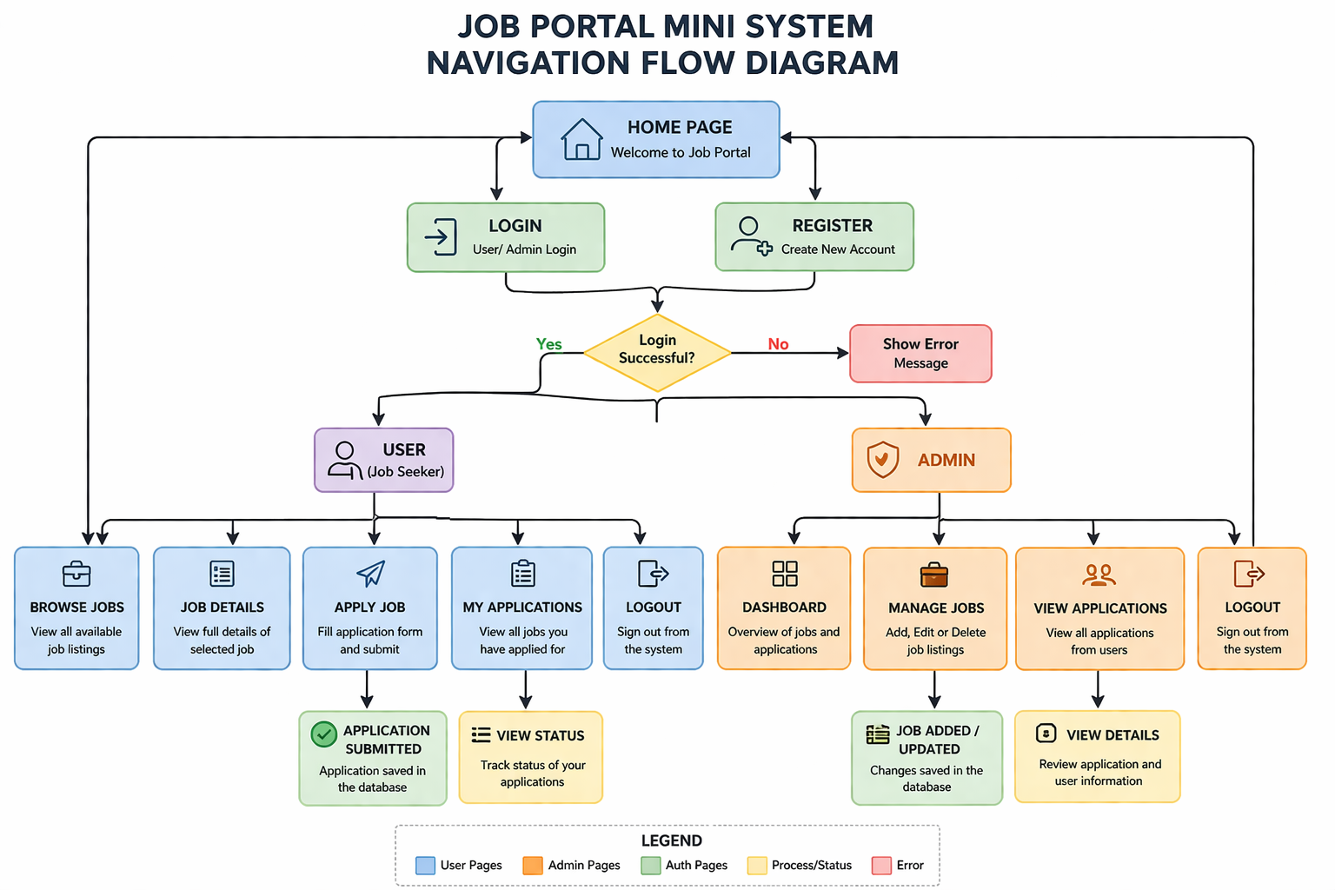

- IMPLEMENTATION

5.1 Frontend Development
The front-end of the Job Portal System is created based on HTML, CSS, JavaScript, and Bootstrap. The primary concern was to design a user-friendly, clean and responsive interface that enables users to interact with the system.
Various pages including the login, registration, job listings, application form and the administration dashboard are developed using bootstrap elements such as forms, cards, and navigation bar. JavaScript is used to handle user interactions and communicate with the backend using the Fetch API.
The frontend also makes sure that user inputs are well validated and that the user experiences success or error messages, enhancing the overall user experience.

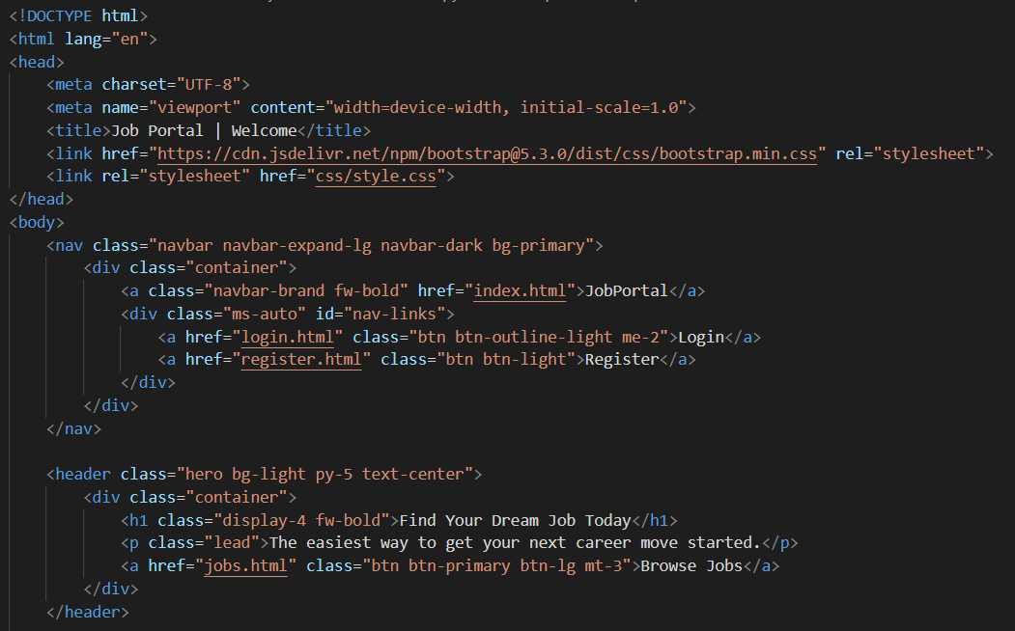
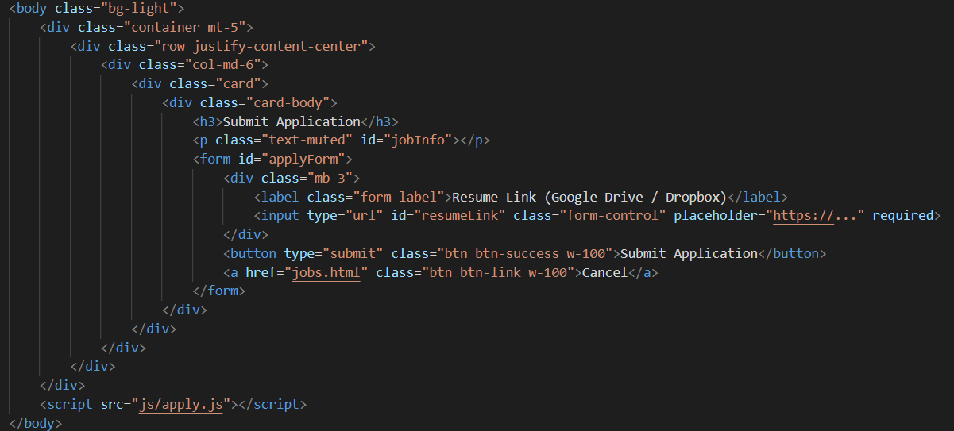
5.2 Backend Development
The server side is written in Node.js and Express, which deal with server-side routing and the creation of API. RESTful APIs are designed to handle the authentication of users, job operations and application control.
Prominent features encompass registration and log-in of users, creating, updating and removing jobs by the administration, and application of jobs by the users. JWT (JSON Web Token) is employed to authenticate and authorize access to secure routes so that only authorized users can access them.
The backend is designed to have a modular architecture with routes, controllers, and middleware separated to ensure improved maintainability and scalability.
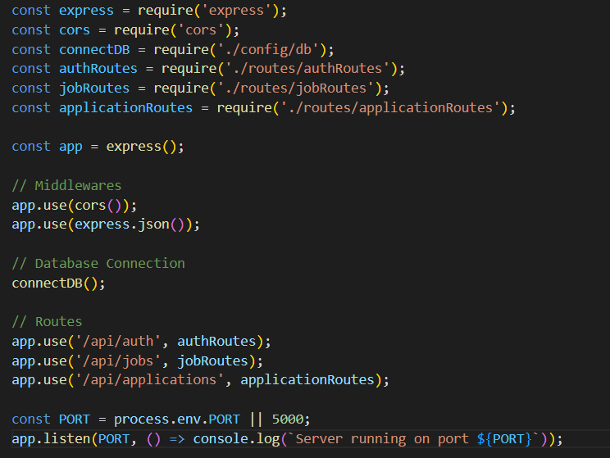
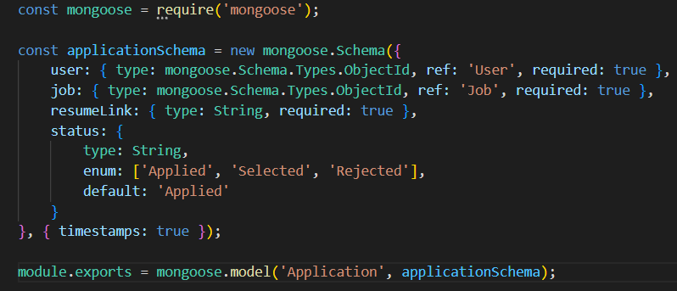
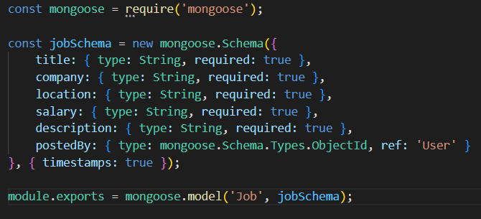
5.3 Database Implementation
The database is stored in MongoDB where all the application data such as users, job listings and applications are stored. Mongoose is employed to describe the schema and to operate data.
Three main collections are created: users, jobs, and applications. ObjectId reference is used to maintain relationships between these collections. The database will enable the efficient storage and retrieval of data, needed to accommodate all CRUD operations necessary to the system.
All in all, the frontend, backend and database integration will secure a proper flow of data and effective operations of the application.
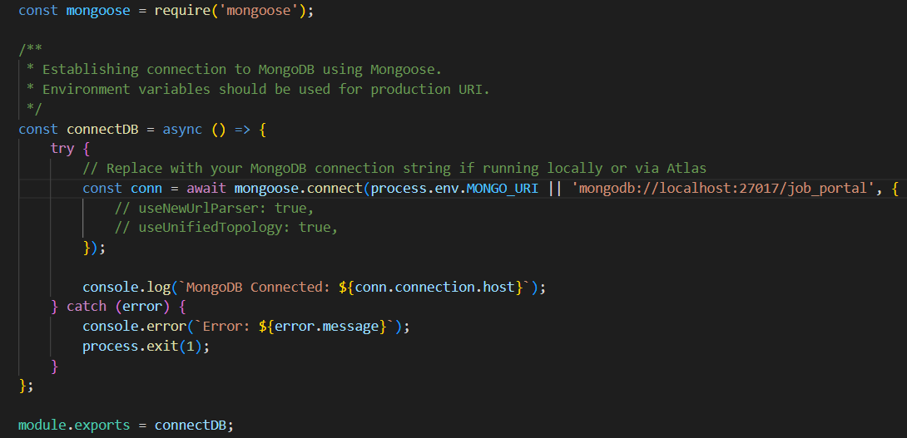

- RESULTS

6.1 Final Application Output
The Job Portal Mini System was developed and tested successfully and met all the desired requirements. The app has a user-friendly interface to both users and administrators.
The system enables one to create an account, log in, use the site to search and apply to jobs. In a similar manner, the admin has the ability to control job posting and see user applications via a special dashboard.
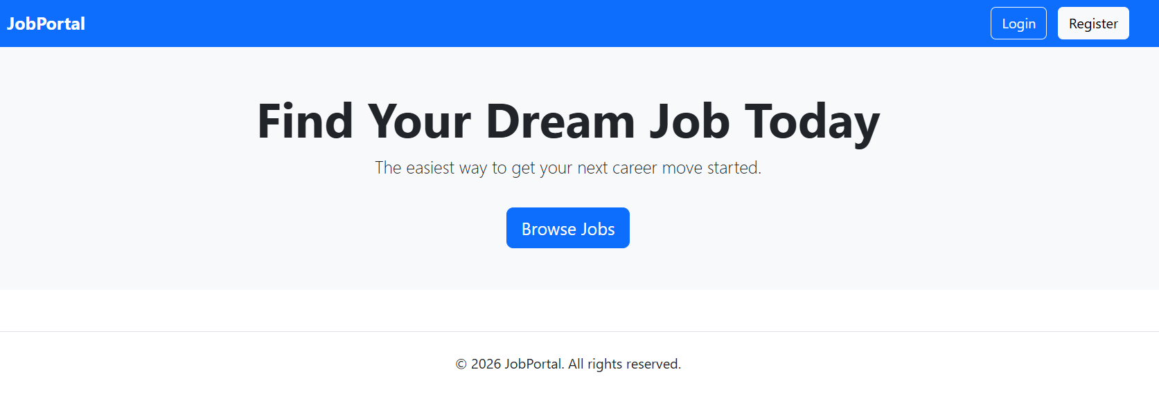The home page offers the navigation to the login and registration in a well-structured and user-friendly interface.
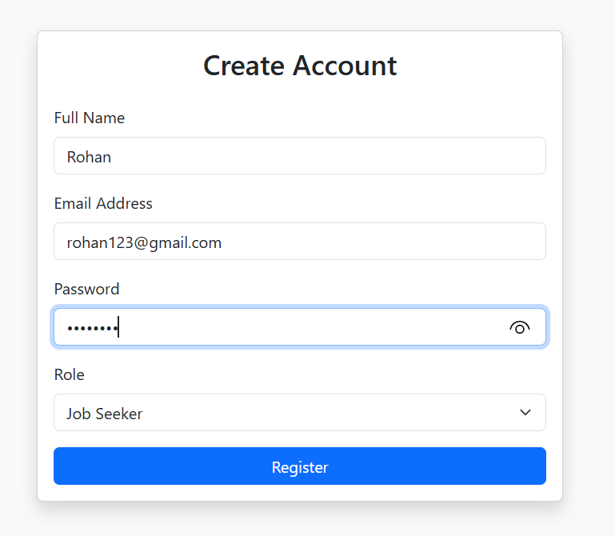
The user can create an account by providing his or her basic information like name, email, password, and role.
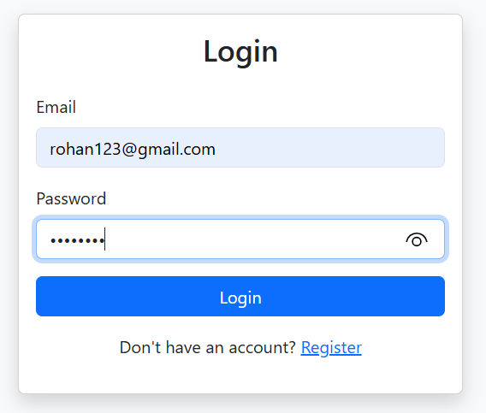
Users can log in using their credentials in a secure manner.
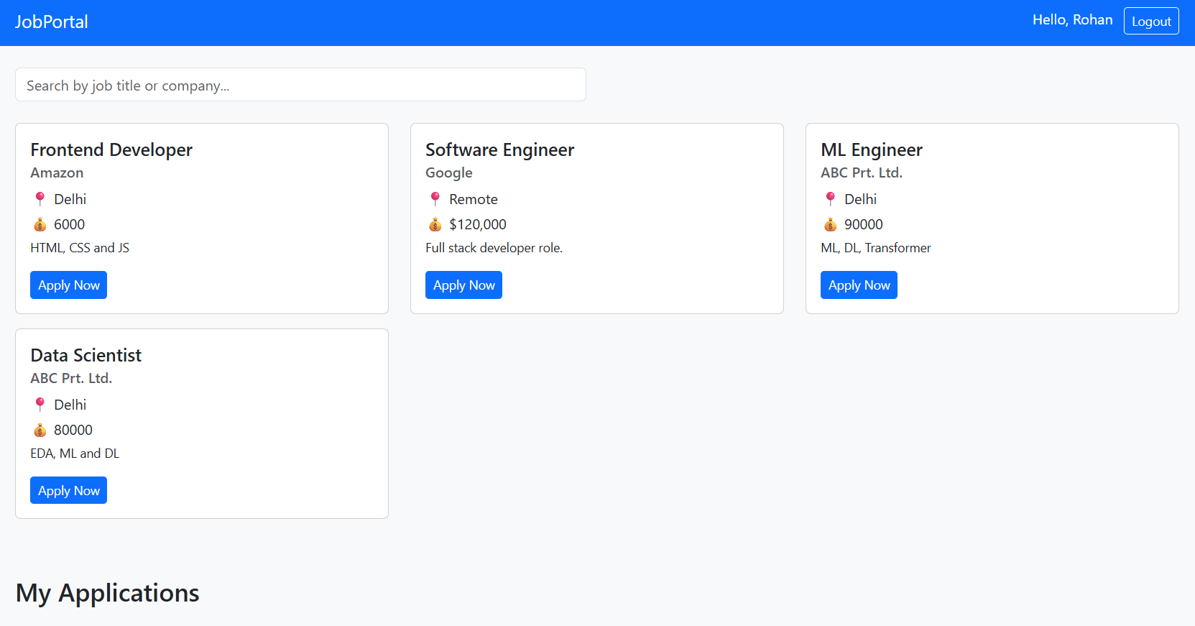
Shows all posted jobs in a card format including information such as title, company and location.

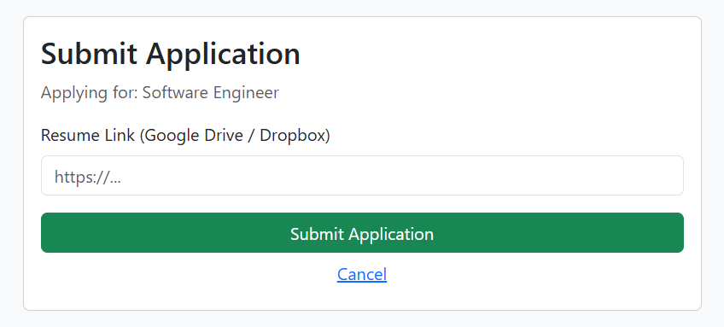Users are allowed to apply to jobs using necessary information like resume link.
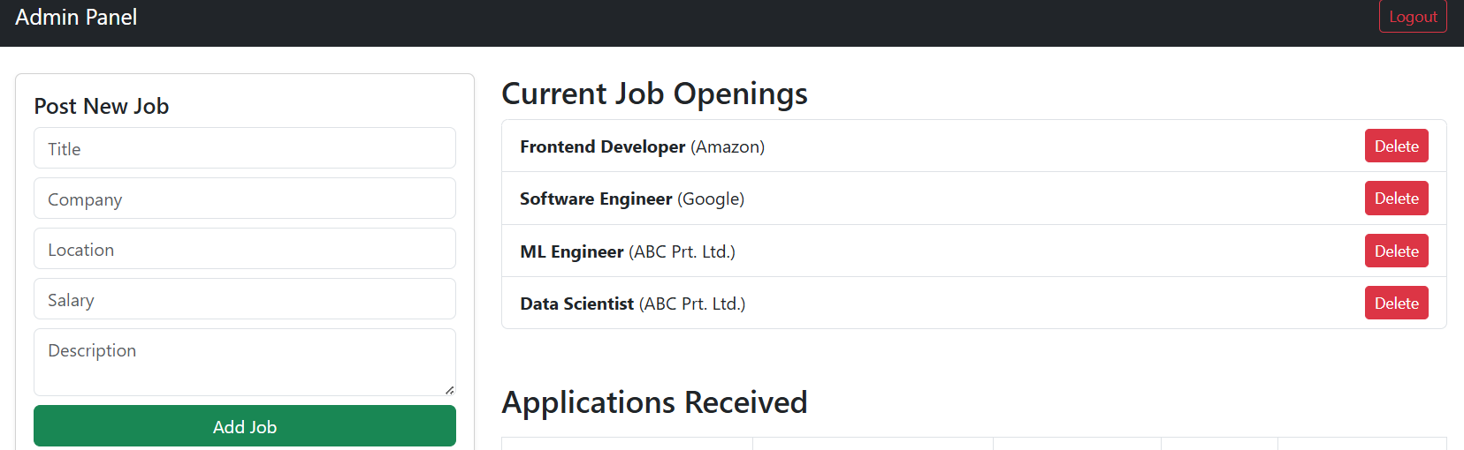
Admin is able to add, edit or delete job listing and administer applications.
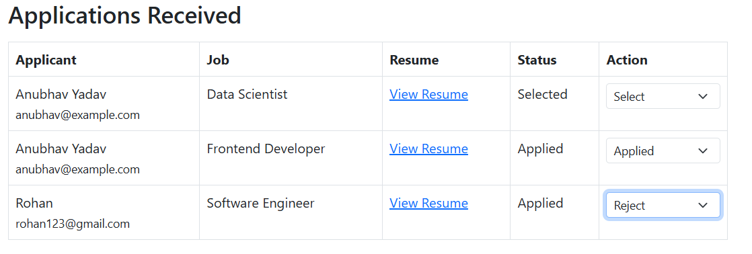Admin is able to see all applications that have been submitted by the users and pertinent information.

6.2 User Experience
The system offers an easy and user friendly user interface. The navigation is simple as one can easily navigate between different pages without losing his or her way.
The use of Bootstrap ensures that the application is responsive and works well on different screen sizes. Form validations and alert messages assist the user to understand errors and actions well.
By and large, the application is efficient and all features behave as intended which gives an excellent interaction between the user interface, backend server and database.

- CONCLUSION AND FUTURE SCOPE

7.1 Conclusion
The Job Portal System has been designed and developed successfully and based on modern web technologies. The project fulfilled its main objective of developing a full-scale web application with full-fledged CRUD operations, user authentication and database integration.
The system offers an effective platform through which job seekers can search and apply to jobs, and also allows administrators to effectively manage job listings and job applications. Frontend, backend, and database integration guarantee smooth data flow and high-performance.
The project also assisted in learning the practical implementation of the full-stack development, such as the creation of APIs, the management of the database with the help of MongoDB, and the provision of the security of the product with the help of JWT. In general, the project illustrates how web development concepts can be applied in real-life scenarios.

7. 2 Future Enhancements
Despite the fact that the system works, there are a few areas of improvement that can be made to increase its potential:
- Introduce powerful search and filtering of jobs.
- Include resume upload and not links only.
- Add email notifications on the status of the applications.
- Have a more advanced administrator panel with analytics.
- Add user profile management.
- Enhance UX/UI using new frameworks such as React.
These improvements can transform the system into a more scalable, user-friendly, and more lifelike job portal systems.

7.3 GitHub Repository
The entire source code of the project can be found on GitHub.
GitHub Repository Link: https://github.com/AnubhavDataSci25/AIP-Mini-Project-Sem-2
These connections enable easy access to the project to test, evaluate and develop in the future.

- REFERENCES
The following resources were referred to during the development of the Job Portal Mini System:
- MongoDB Official Documentation – https://www.mongodb.com/docs/
- Node.js Official Documentation – https://nodejs.org/en/docs
- Express.js Documentation – https://expressjs.com/
- Bootstrap Documentation – https://getbootstrap.com/docs/
- MDN Web Docs (HTML, CSS, JavaScript) – https://developer.mozilla.org/
- JSON Web Token (JWT) Documentation – https://jwt.io/
- Mongoose Documentation – https://mongoosejs.com/docs/
These resources provided guidance for implementing backend APIs, database integration, frontend design, and authentication mechanisms used in the project.

